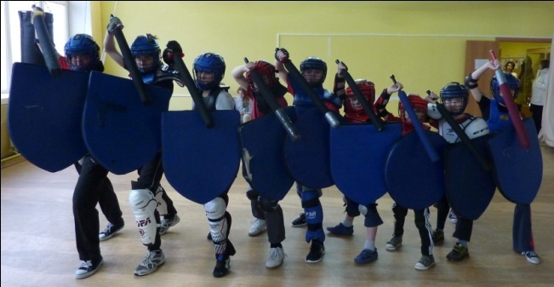
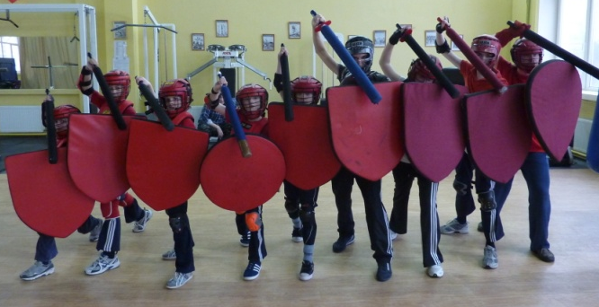
«Team battles 5-by-5»
Additions to the MSF Competitions Rules in 2012-2015 academic years
This nomination is experimental and is introduced at the competitions of the season 2015-2017 to promote mass action with the use of MSF equipment and to develop skills in tactical command of interaction MSFF athletes.
Participation: All participants of "Team battles 5-by-5" MUST provide for registration before the event a certificate from the attending physician or the place of study, that an athlete has no contraindications to train MSF. Children in the nomination 12-13 years are additionally required to provide a certificate from their parents that they do not object to their child to participate in these competitions - "the Team battles 5-by-5".
Team composition: this nomination will be held in mixed teams in five age categories - 8-9 years, 10-11 years, 12-13 years, 14-15 years, 16-17 years. And girls and boys can be together. The team can consist of minimum 4 people, maximum of 7. In case, if a team is only 4 fighters, the command of their rivals has the right to act against them as 4 and 5, at their discretion. Each team should have the Captain, who acts on behalf of his team. The other men of the team have no right to argue with referees or act on behalf of the team. Each team can have 1-2 spare fighters.
Replacement of fighters: In the second and in the third round there may be 1 replacement. The decision on replacement of fighters is taken by the Captain. If by decision of the Doctor of the Competition, two other fighters in the same team can't continue fighting, it is allowed to make two replacements in a single round at once. The interval between rounds should not exceed 2 minutes.
Battles rules: fight is carried out in 3 rounds to capture the flag. The task is to capture the flag of the opposing team and keep yours in such a way that BOTH flags were on the same basis. If one team wins 2 rounds in a row, then the third round is held still. All fights are conducted in a standardized sports weapons MSFF, only with the use of shields and swords. Other types of weapons (bucklers, the two swords, two-handed swords) are not allowed. If a fighter by mistake brings flag on the base of the rivals, the winner of the round is awarded to the team on whose basis both flags occured.
Each fighter has 2 "points of life." The affected area is ‘full", including the head, neck to the side, body, shoulders, arms and hands, legs without feet. Accented cutting strike with the first third of a sports sword takes from the fighter 1 "point of life." The fall (or touch the earth with the third point of support) takes from the fighter 1 "point of life." The fall twice, the fall + shot, two shots - cause the defeat of the fighter in the current round (he should show it for everybody by sitting down on the squat or on the floor). Targeted falling, getting up on the knee, rolling - are equal to fall - fighter loses "1 point of life." To rest on a shield or a sword to prevent dropping are allowed. The loss of weapons does NOT stop the fight.
Forbidden: to beat in the head, in the neck and the base of the skull in back of throat front, in the groin, in the foot. Forbidden thrusting hits, unarmed combat, hitting with the edge of the shield, pull the flag out of the hands by force.
The beginning, stops and the end of the battle.Before the beginning of each round fighters line up near their base, forming the original position. The Chief Referee gives a voice command: "Red team, welcome!", "Blue team, welcome!", "Fight!" and gives a whistle. In the case of complex, controversial, dangerous situations, violations of the Rules, or when one team brings the second flag on the base, the Chief Referee gives a long whistle in a sign of the end of the round. The actions before the start and after the final whistles do not count.
Uniforms: Each team before the battle puts special capes of one color (red or blue). On the back and chest each fighter has a number from 1 to 5 in the red team and from 6 to 10 in the blue team. The capes are provided by the Organizers. The teams are equipped with the shields of red and blue colors with corresponding numbers. The helmets of the fighters from the red team must be either red or black. On the fighters should not be blue items of equipment, unless it's their club uniforms (for example, blue t-shirts). For the "blue" team - blue shields, blue or black hats, blue capes, blue security features.
Refereeing:Each round at the same time judges from 9 (if the teams are fighting in incomplete composition on 4 fighters) to 11 referees (in full composition of 5 fighters), including the Chief Referee. Each referee assigned to a fighter and is equipped with a large (red or blue) card number of the fighter, and must keep track of what is happening in the immediate vicinity. Referees have the right to move along the boundaries of a Site from the outside to have a better view of their fighters. If the fighter that is being monitored by the referee leaves, the referee switch to any other fighter in the same team and monitors him. If some fighter having 2 strikes doesn’t sit down within 2 seconds, the referee should signal about that to the Chief Referee lifting up the card of his fighter and voice commands like "the Fifth sits down!". If the Side Referee considers the actions of a fighter, for whom he attended, wrong, and has recorded a violation of the Rules, he may invite the Chief Referee to issue a "Yellow card" and must justify his opinion.
Ethics: the Responsibility of all fighters to play fair! Chief Referee on the recommendation of the referees has the authority to order the fighter a "Yellow card" if: a fighter systematically (more than 2 times) plays not fair – he does not sit down after receiving second shot, does not consider his "life points" and so on; if the fighter intentionally beats too much in the danger zone (head, back, kidneys, knee bend, palms) to cause bodily injury; intentionally rises, moves, prevents others, screams, commands, etc. once received his two strikes and sat down; allows obscene words on the Site; negative comments on the rivals or the whole team, referees, activities, spectators, etc.; behaving inappropriately; putting pressure on referees; deliberately damage inventory, equipment or interior; is in a condition of alcoholic or narcotic intoxication. When receiving two Yellow cards", a fighter receives a "Red card" and disqualified till the end of the competition. Fighter scored 5 Yellow cards in one season (one academic year) is disqualified till the end of the season, and his team receives a "Team yellow card". The team awarded two “Team yellow cards” in the season gets "Team red card" and disqualified till the end of the season in full.
Battle site border. Output two legs out of the Site leads to the loss to the fighter in this round. Exit abroad with one foot can last no longer than 2 seconds. If the fighter has transferred his weight on the leg, which is out of the Site, and the second leg is clearly in the air, the fighter leaves this round. Popping abroad grounds permitted but discouraged. Shield tremors for less than 2 seconds are permitted. If one fighter, pushing out another, receives 2 strikes, but the second is out of the Site, both fighters lose this round. If popping occurs immediately after pushing fighter got 2 strikes, the fighter, who found themselves out of the Site, comes back in the fight as a closest Side Referee.
Flags and bases. Bases are round shields with a diameter of 75-80 cm of red and blue colors, located on the floor in the middle of short boundaries of a Site, 1 m from the edge. The flag is made of a flexible plastic shaft with safety tips and tissue box, about 30x50 cm. Flags lie on the bases and may not be moved by its team. You can't take your flag and go with it to battle. The flag should not be held on the base with the hands, feet, all the weight of the body, arms, etc. If the opponent took the flag from your base, you need as soon as possible to return it back. The flag can be thrown, transferred, put on the floor. The flag cannot be fixed by the straps of the shield, by the belt etc. Flag cannot be beaten, but it can reflect the strike. If the flag touches with the shaft or fabric a part of a Base, it is considered that it is based. If the flag does not touch any part of the Base, it is considered that it is not on the Base. If the flag has flown over the Base and touched it, but by inertia flew on, it is believed that when both flags were based, the round is ended by the victory made by this team. If the fighter carrying the flag to its Base gets the second shot, he is OBLIGED to IMMEDIATELY drop the flag (not to throw in some direction, and just drop right on the spot!) and as soon as possible to stop and sit down. To throw the flag through all the field is forbidden.
These rules are the experimental activity of the MSF and are subject to change. All changes must be published on the website of FSMB of Russia.
Version 1.0 dated 10.10.2012

