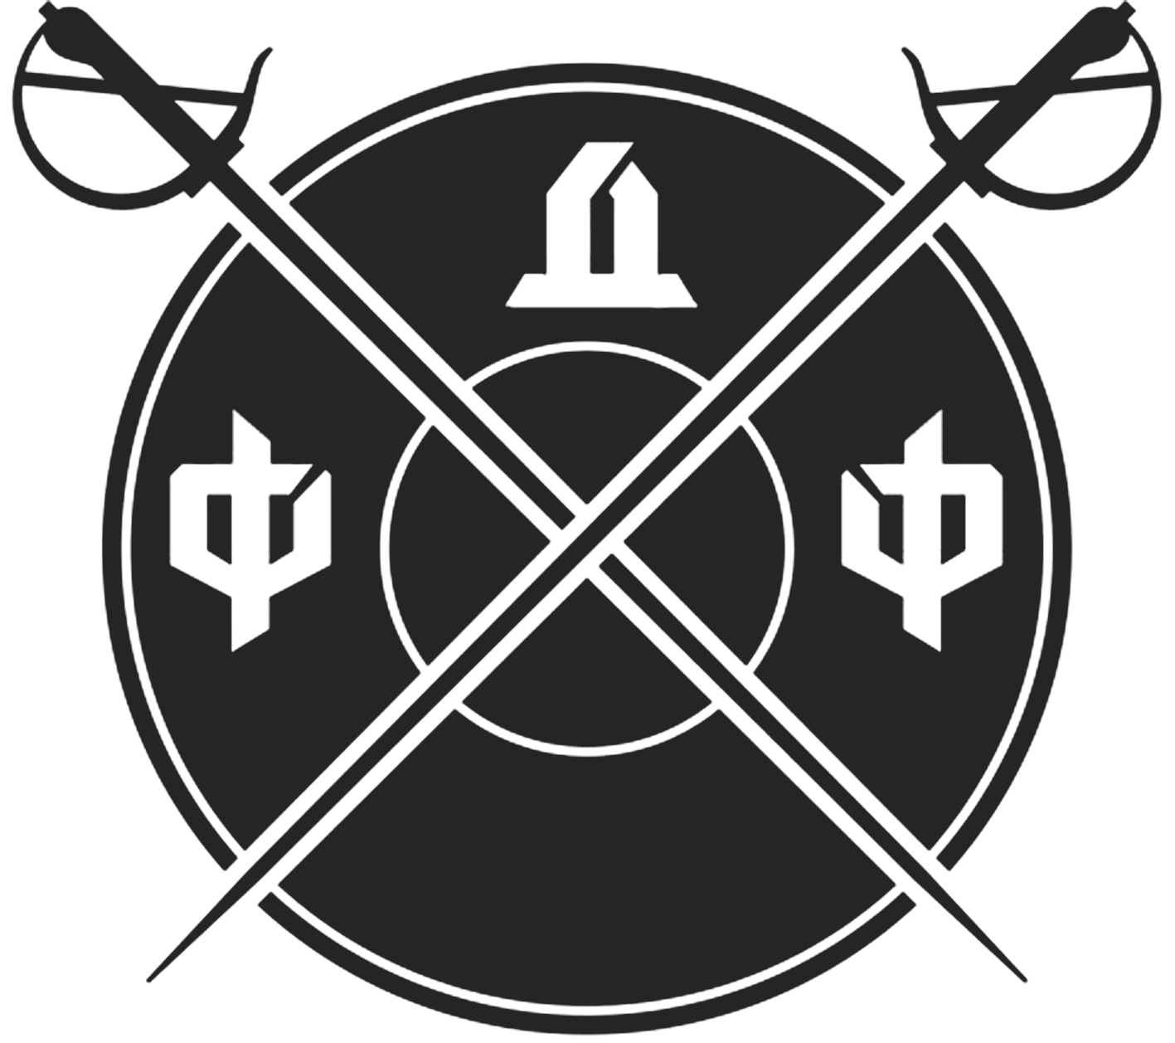

Rules of “MSF dueling sabre” nomination
Version 1.1 of 10.02.2018
General regulations.
- “MFS dueling sabre” nomination is introduced in order to implement the agreement between the Federation of Duel Fencing (FDF) and Interregional physical culture and sports non-governmental organization “The Federation of the Modern Sword Fight” (IFMSF), as well as All-Russian physical culture and sports non-governmental organization “The Federation of the Modern Sword Fight of Russia” (Further – FMSFR).
- Introduction of this nomination with protected safe model of a duel sabre will let children and adolescents practice duel fencing and will foster the development of the skills, which are necessary for practice of the duel fencing – sport area of Historical European Martial Arts (HEMA).
- This document describes the Rules of the nomination, based on principles of the FDF and the IFMS, as well as the next preconditions:
  - The Rules should be simple for understanding and utilization.
  - The Rules should encourage the improvement of techniques and tactics of historical fencing.
  - Preferentially for the Rules to comply with one of existed types of weapons and described manners of its use.
- As a weapon for p.3 realization XIX c. military/dueling sabre is chosen – weapon, which was used throughout the Europe and outside it, techniques of using and teaching of which are extensively documented.
- Competitions are held in accordance with the IFMSF and the FDF regulations, taking into account this Rules and prescribed in Regulation on competition.
- Each Regulation should be approved by significations of the IFMSF and the FDF Presidents and sealed by the Organizations.
- On the basis of the Competitions the Final Protocol preparation and publication on the official Federations resources are mandatory. Without publication of the Regulation and Final protocol the results of competitions will not be validated.

General provisions of the Rules conforms to the IFMSF Rules version 6.0:
- Medical services,
- Sportsmen insurance,
- Division into Leagues,
- Age categories.

Next provisions are on the organization choice and should mandatory be included in the Regulation on competition:
- Division into pools according to the amount of sportsmen.
- Competitions grid.

Membership in Federations:
- Membership in the IFMSF and the FDF in 2018 is desirable and recommended, since 2019 – required.
- For affiliation into Russia National MSF team to “European MSF Championship 2018” the IFMSF membership is required.

Тerms and definitions:
- “Weapon”, “Sword”, “Sport sword”, “dueling sabre” – sport equipment, described in p. “Offensive weapons”.
- “Hilt”, “Non-combat part” – a part of sabre consisted of handle and guard.
- “Blade”, “Combat part” – a part of sabre except for the hilt
- “Back”, “False edge” – concave side of blade.
- “Cutting edge” – convex side of blade (from the side of first phalanges of sportsman’s hand).
- “Flat of the blade” - side surface of the blade between edge and back.
- “Point” - furthest from the handle end of the blade.

Arena:
- The competition is held on a square (7x7 metres) or rectangular (6x9 metres) flat firm surface - “arena” or “ground”, its perimeter is marked with white line (at least 5 cm width). Masking tape is recommended since it does not leave a trail on any covering. The safe zone should be at least 1 metre from the perimeter of the arena.

Judges appearance:
- Judges appearance - mandatory: black trousers or black jeans; white shirt or white judge polo from the FMSF or white judge T-shirt from the FDF.
- Other colored clothes (shirts, turtlenecks, thermal underwear, rashguard or other visible from under white shirt) under white shirt, T-shirt or polo are prohibited.
- Judges in slippers, sneakers, sandals, blue jeans are not allowed to work and get -1 point for judging practice.

Sportsmen’s appearance:
- All the sportsmen should be clean, tidy. Sportsmen wearing shorts, jeans, camouflage, vests, breeches with stripes or bright spots, non-sportive shoes (boots etc) or no shoes at all.
- All representatives of a club should be dressed uniformly
- A sportsman without club’s uniform is allowed to the competition only if he is wearing universal sport clothing: white t-shirt or turtleneck without pictures, long black sportive breeches (deep dark blue or grey is allowed)
- Attention! The people who are not dressed in accordance with the requirements will not be allowed to the competition!

Protective equipment:
- All the participants must use protection for body, groin, throat, head and the sword hand.
- Mandatory equipment includes helmet of type Ш11ИВ (made by ООО «Ray-Sport» or PA «Sport Kuznya») with additional neck and back of the head protection, body protection of type Ж16 (or its varieties), any groin protection with a plastic cap.
- All the protection elements must be red, blue or black. Other bright colours are not encouraged.
- It is allowed to use club symbols in the form of patches, emblems, in the safe for the sportsman and his opponent way.
- For sportsmen older than 18 years it is allowed to use sport fencing mask as the head protection.
- Quilted (padded) protection is allowed only for hand protection.
- Sword hand must be protected by at least full-fingered thick leather glove or padded glove.

Weapons/ attacking equipment:
- Sport fights in the discipline “dueling sabre”, in which thrusts are allowed, are conducted using special safe sport wasters made by PA “Sport Kuznya” for sportsmen older than 12 years.
- Use of the alternative attacking equipment is allowed only in case of preliminary agreement with Presidents of FMSFR and FDF and must be stated in the Regulation.

Competition rules.
Prohibited area:
- Sword hand
- Groin
- Back of the head
Allowed area:
The area allowed for all attacks includes full body except for Prohibited area.
Allowed techniques:
- Cuts and thrusts with the blade of the dueling Sabre to the Allowed area of the opponent;
- Parrying the opponent's attacks with the blade and the guard of the dueling sabre;
- Pushing of the opponent’s hands and arms
Prohibited techniques:
- Strikes to the prohibited area;
- Attacking of the fallen or standing up opponent;
- Attacking of the opponent who have lost his sword;
- Attacking after the “Stop” command by the Referee;
- Strikes with the head;
- Strikes with the feet and knees;
- Throws, grappling, joint locks;
- Strikes with the hands and elbows;
- Strikes with the guard of the dueling sabre;
- Grabbing of the opponent’s body, head and limbs, as well as of his protective equipment and weapon.
Scoring:
- Thrust to the head, neck or body is worth 3 points;
- Cut to the head, neck or body is worth 2 points;
- Cut or thrust to the limbs is worth 1 point;
- Cut or thrust to the limb, covering the head or the body from the strike is judged the same as a strike to the covered area (2 or 3 points)

The following actions are not scored as valid strikes:
- Cuts with the flat or back edge of the dueling sabre.
- Strikes with the Forte (closest to the handle third part of the blade);
- Strikes without sufficient strength or amplitude;
- Slipped (without fixation on the allowed area) thrusts;
- Cuts that landed by the use of the inertia and flexibility of the dueling sabre, “whips over”.
Conduct of the bout:
- The bout lasts for 2 minutes of total time. The time is not halted at the moment of scoring and return to the positions. If the technical pause in the fight lasts longer than 5 seconds, the timer is stopped.
- If one of the fighters has an advantage of 10 points or more (score 10-0, 15-5), the bout is ended before time.
- The fight is stopped instantly after any valid strike, after that the points are scored.
- In the case of simultaneous (double) strike the difference of the points obtained is scored
- In case of three double in a row, independent of the points scored, the fight is ended, and both of the fighters are considered to lose the fight with the score 0-0. This rule is not applied in the playoffs and finals.
- In the case of clinch (physical contact of the fighters’ bodies) the fight is stopped after 3 seconds.
- In the case of one or both fighters leaving the ground, the fight is stopped and the fighter who have not left the ground gains 1 point.
- In the case of one or both fighters falling, the fight is stopped and the fighter who have not fallen gains 1 point.
- In the case of one or both fighters losing their weapons, the fight is stopped and the fighter who have not lost the weapon gains 1 point.
- If a fighter receives a valid strike simultaneously with leaving the ground, losing the weapon or falling, only the strike is scored.
- If a fighter lands a strike simultaneously with leaving the ground, losing the weapon or falling, this strike is not scored.
- Fighter who has more points in the end of the bout wins the bout. In case of equal score, the bout is considered a draw in the pools, and in the play-off or finals, an additional sudden death round is conducted.

Competition regulations.
- All the competition regulations, including the rules for the determining of the winner, are according to the Regulation on the competition.

